Media viewer project

Product goal : Be able to visualize pictures, video and sounds of all format : jpeg, png, bmp, mpg, mpeg, mp4, mp3, wav, with a user friendly user interface in windows OS. The soft will be installed via an installer that provides all dependencies.

Product backlog items :
- Have a user interface that can visualize all format pictures.
- Have a user interface that can visualize all format videos.
- Have a user interface that can read all format sounds.
- Have an installer to install the Media viewer project.

Sprint One

Duration
- 09/07/2025 – 23/07/2025

Goal
Have all the menu available and be able to install the version on windows. Have some fun icon & name for the application.

https://tree.taiga.io/project/hicham7995-media-viewer/backlog

Items

First item
Be able to display all menus and their content see :
Given I launch the picture view application
When the main window is displayed
Then I should all the menus and their content as listed below.

The user interface has a menu :
  - File, Edit, View,Image,Filters,Tools,Window,information
  - 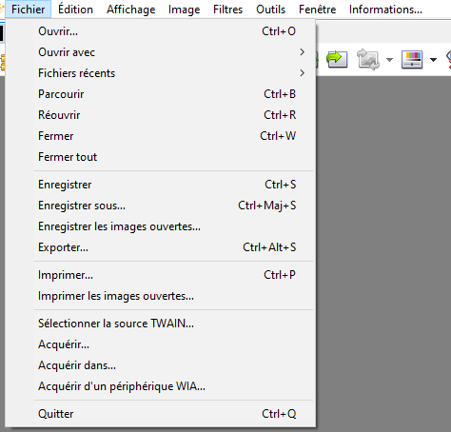
  - File:
    - Open
    - Recent files
    - Browse
    - Close.
    - Close all.
    - Save
    - Save As
    - Print
    - Quit
  - Edit :
    - Cut,
    - Copy
    - Paste
    - Delete
    - Rename
  - View :
    - Full screen.
    - Real size
    - Adjust :
      - No Adjustment
      - Adjust to the size of the window
      - Adjust to the width of the window
    - Zoom +
    - Zoom -
    - File
      - Next File
      - Previous File
      - Last One
      - First One.
    - Display Tabs
    - Display Tool bar
    - Display State bar
  - Image :
    - Number of used colors
    - Rotate
      - 90° clock wise
      - 90° reverse clock wise
      - 180°
    - Mirror :
      - Vertical
      - Horizontal
    - Resize
    - Correct red eyes
  - Tools:
    - Find a file
    - Hexadecimal display
    - Diaporama
    - Send by email
    - Parameters
    - Slide Show
    - Show pictures on all the screens : Place the selected pictures on the screen
  - Window :
    - Tile (en cascade)
    - Tile horizontally

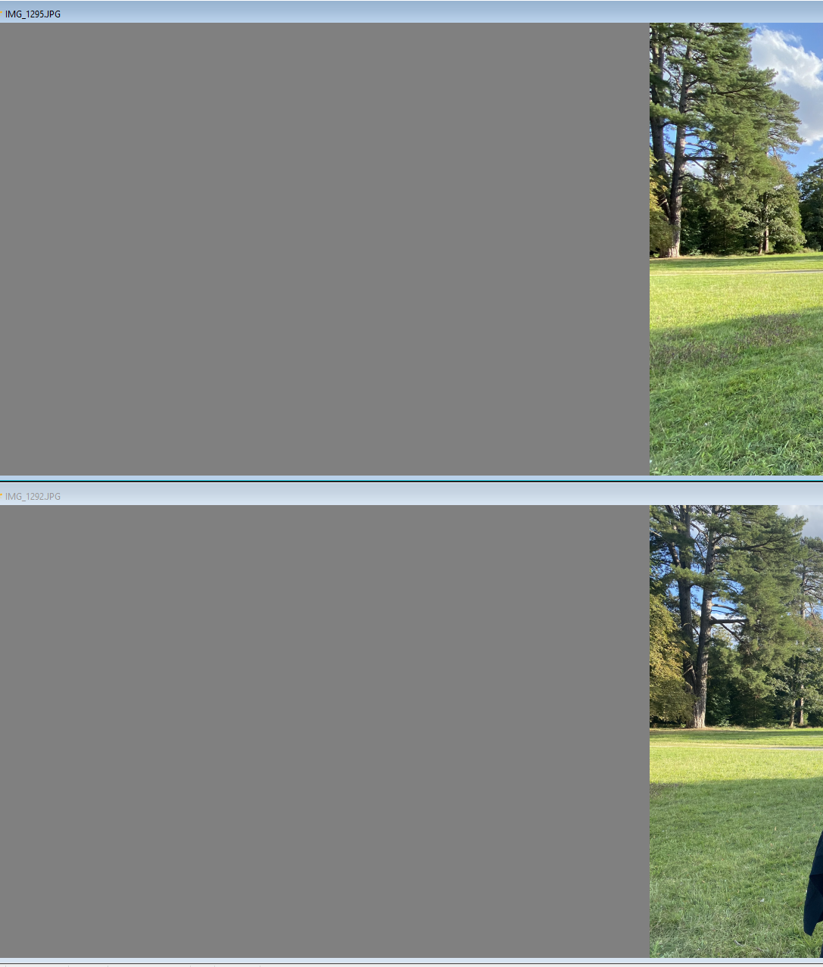
- Tile Vertically
- Minimize all
- Restore all
- Info :
Help

Second item
Given I lauch the picture view application
When the main window is displayed
Then we should see « Media Viewer » in the title bar on the left side of the window + an icon

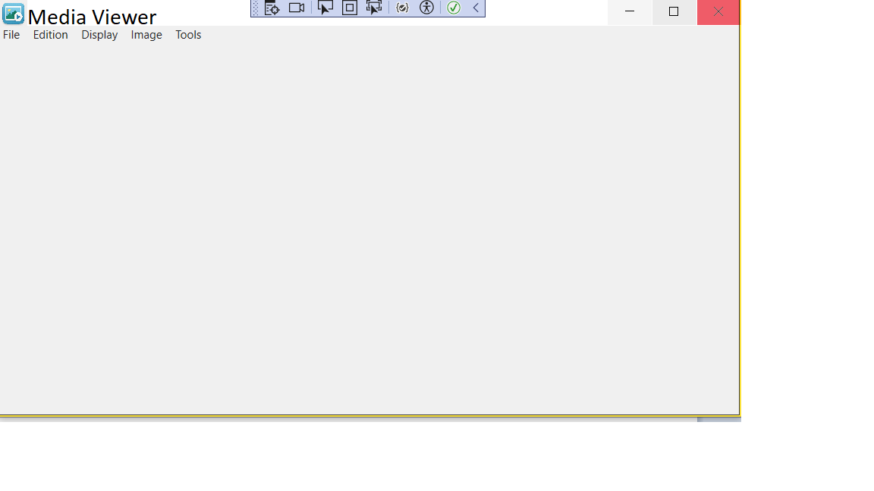
Third item
Given I reduce the window
When the application is reduced and visible in the task bar
Then the Main icon should replace it

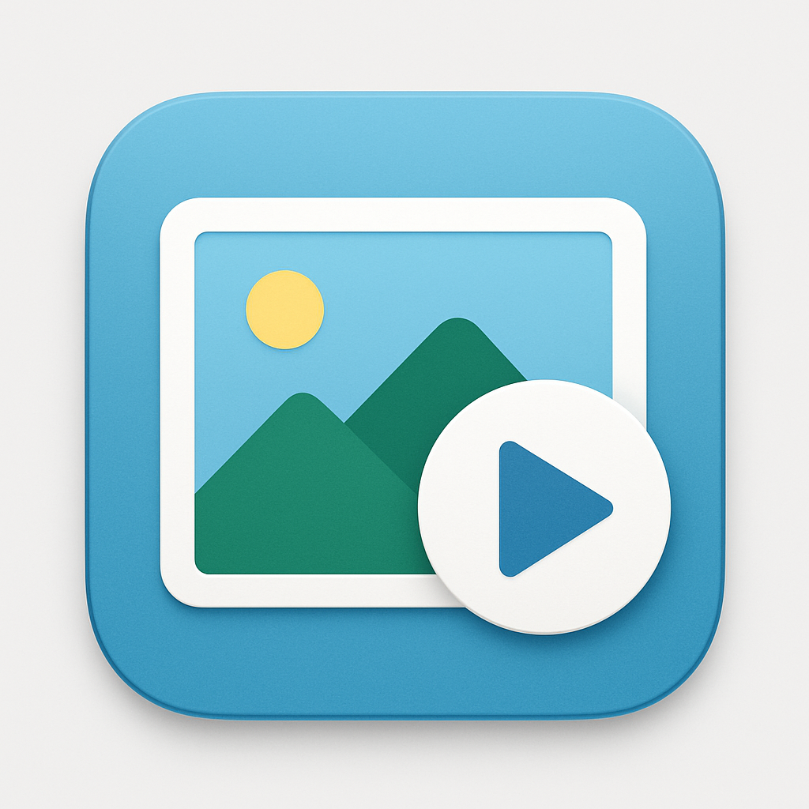

Fourth item
Create the installer for the application
Complete documentation :
https://learn.microsoft.com/en-us/visualstudio/deployment/installer-projects-net-core?view=vs-2019
Here the procedure :

✅ Step 1: Install Visual Studio Installer Projects Extension
- Open Visual Studio 2022.
- Go to Extensions → Manage Extensions.
- Search for: "Microsoft Visual Studio Installer Projects".
- Click Download and then restart Visual Studio to complete the installation.

✅ Step 2: Prepare Your WPF Application
Ensure your WPF application builds correctly in Release mode.
- Set your WPF app as the Startup Project.
- Build your project in Release configuration (Build > Configuration Manager > Release).
- Note the path to the compiled .exe, usually in:
bin\Release\net6.0-windows\YourApp.exe (or .NET Framework version depending on your project).

✅ Step 3: Add a Setup Project
- Right-click on your solution → Add → New Project.
- Select Setup Project (found under i Project Types > Setup and Deployment).
- Name it something like MyAppInstaller.

✅ Step 4: Add required files to the installation project
- In the Solution Explorer, right-click on the Setup Project → Add → File.
- In the dialog:
  - Select all required file to be installed :
      - PictureView.exe ,PictureView.runtimeconfig.json, PictureView.dll
  - Click OK.
This ensures the .exe and necessary .dll files are included in the installer.

✅ Step 5: Customize Installer (Optional but Recommended)
Add a Shortcut:
- In the File System editor of the setup project:
  - Right-click User’s Desktop → Create New Shortcut.
  - Link it to the PictureView.exe file

Add an Icon (Optional):
- Add your .ico file to the setup project.
- Right-click your shortcut → Properties → Set Icon to the added .ico file.

✅ Step 6: Build the MSI Installer
- Set the Setup Project as the startup project.
- Right-click on the Setup Project → Build.
- After build, you’ll find the .msi file in:

Display an opened file
Given I click File→Open
When A file open dialog appears
Then I should be able to read a file and to load it in the screen
And it should be added on the recent menu

Browser mode

Menu
File
Open
Recent Files
Close
Close All
Edit
Cut
Copy
Copy Image Data

View
View As
Thumbnails
Thumbnails & Labels
Icon
List
Detail
Sort By
Name
Extension
Date

Given I click File→Browse
When no file is opened
Then I should see on the left a file browser pane opening on the last folder opened
And on the right I should see the content of the folder as Icons
And Menu should switch to browser mode

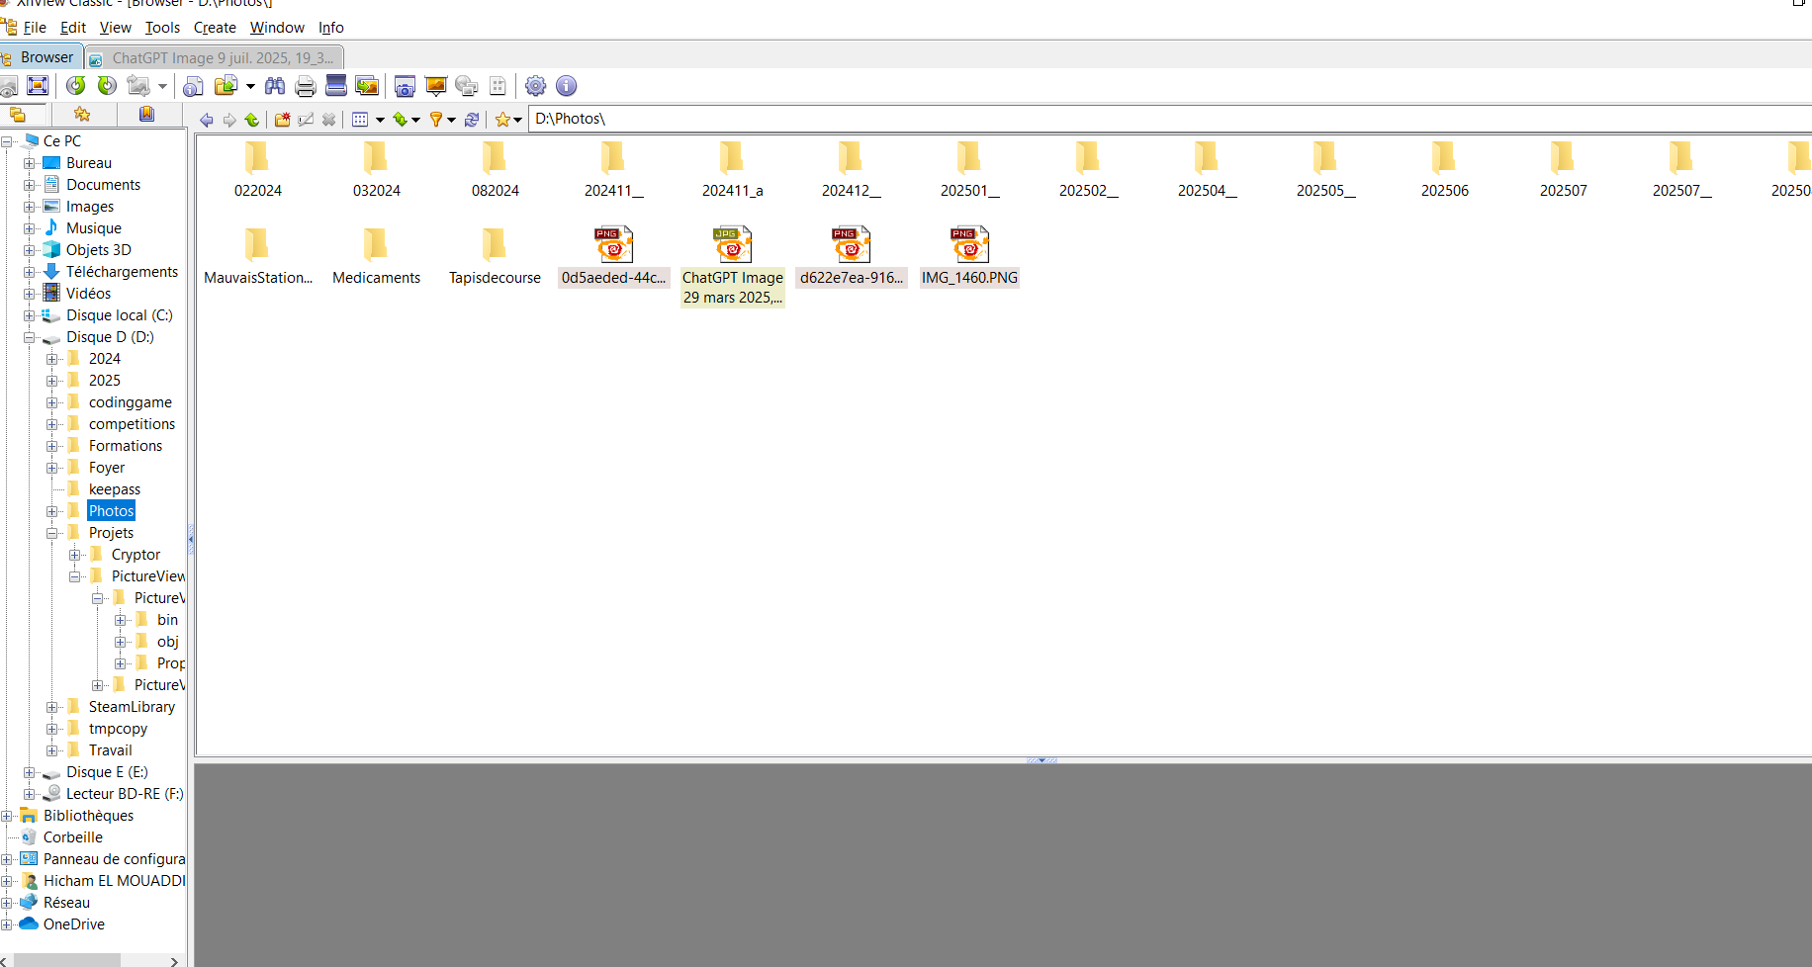

Given I click File→Browse
When a file is opened
Then I should see on the left a file browser pane opening on the folder of the file
And on the right I should see the content of the folder as Icons
And Menu should switch to browser mode

Given I click File→Browse
When the left pane contains the explorer pane
And when I change the folder selection on the left pane
Then I should see the content of the new folder as Icons
And Menu should switch to browser mode

Given I click File→Browse
When the left pane contains the explorer pane
And when I click on the top right corner of the window
Then It should close the browser mode

